Digital Visit
Digital support and internet advice for
Parish and Town Councils
Parish/Town Council

Contact name

Position/role

Email address

Telephone

Please specify what you would like advice on. The more detail you can provide, the better prepared our advisor will be to help you on the day.

Continue overleaf if required

Preferred location for visit
Who will be attending?
(names/positions, we recommend at least 2 people as this helps share learning, continuity, etc.)

Please return to go-online@fastershire.com

or post to Fastershire, Herefordshire Council, Plough Lane, Hereford HR4 0LE

The information you provide will be shared with our Advisor who will contact you to arrange the visit.

Help with your Council’s online presence. Using the internet to engage with communities better.
Help to resolve a specific digital or online problem.

Help and advice can be provided on:-
Websites – maintenance, guidance, how to get a new website or domain name
Sharing information online/in the cloud – documents, diaries, photos
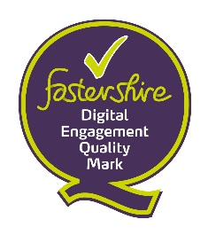
Social Media – Facebook pages/groups, scheduling posts, understanding admin/moderator roles
Email – distribution mechanisms, keeping lists up-to-date, GDPR.
Online accounts – resolving issues
Fastershire is the partnership between
Herefordshire Council and Gloucestershire County Council to bring
faster broadband to the two counties www.fastershire.com

