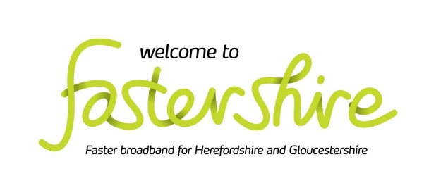

Public Consultation

Fastershire Community Grant

New Procurement vehicle to bring Gigabit Per Second Capable Broadband to the final areas of Herefordshire, Gloucestershire, and a small area of Telford and Wrekin that currently have no route to achieve NGA Capability.

Launch Date: 29/6/2020

Closing Date: 3/8/2020

1. DEFINITIONS

Term | Definition
DPS | means Dynamic Purchasing System, similar in procurement terms to a framework in that it provides a two-stage process to enable Applicants to initially be vetted and accepted as a compliant generic Provider and then to bid for specific projects as they arise as Mini Competitions thereafter;
Fastershire: | means the partnership between Herefordshire Council and Gloucestershire County Council to bring faster broadband to the two counties, with funding from central government’s and local authorities;
Fastershire Broadband Strategy: | means the latest iteration of the strategy found at https://www.fastershire.com/assets/file/FSB%20Strategy/Fastershire_Broadband_Strategy_2019-22.pdf;
Fastershire Community Broadband Grant: | means the funding that will be made available to Grant Recipients to commit to Providers following their successful bid to a Mini Competition;
GBPS Capable: | means services that are capable of transferring data at gigabit per second speeds;
General Block Exemption Regulation: | means Article 52 (Aid for Broadband Infrastructures) of the General Block Exemption Regulation Commission Regulation (EU) No. 651/2014
Grant Recipients: | means an individual or group that have been offered funding from the Fastershire Community Grant;
Intervention Area: | means the UPRNs in the Intended Intervention Area which are not identified by any respondent to this consultation as either having commercial NGA provision or which are planned to achieve such provision via commercial means over the next 3 years within the Response Template;
Intended Intervention Area: | means the full list of UPRNs identified in the Response Template
Mini Competition: | means the bidding stage of the DPS that will be open to Providers to respond to Grant Recipients specifications;
National Broadband Scheme: | means the UK scheme set out in the European Commission document titled SA.40720 (2016/N) - National Broadband Scheme for the UK for 2016-2020 and its predecessor for 2012-2016;
NGA: | means for the purposes of this ITT, infrastructure that offers access to a next generation broadband internet service which deliver a Peak Information Rate of not less than thirty (30) Mbps Download Speed and not less than five (5) Mbps Upload Speed and a Committed Rate of not less than fifteen (15) Mbps Download Speed and two (2) Mbps Upload Speed;
NGA White: | means the UPRNs that will be deemed to be eligible for funding via the Fastershire Community Grant following the conclusion of this Public Consultation otherwise called the Intervention Area;
Providers: | means a broadband infrastructure supplier that has been appointed as a service provider under the DPS.
Public Consultation: | means this consultation which seeks to establish the UPRNs which are to be deemed eligible for the Fastershire Community Grant. It enables all interested stakeholders (including the public, businesses, internet service providers and broadband infrastructure operators) to comment on the proposals. This provides an opportunity for broadband infrastructure providers to review the UPRN list to ensure that no UPRNs are included which are either already servable or are in any commercial or subsidised plan to be enabled with NGA broadband;
Response Template: | Means the excel document available via the Supplying the South West Portal including all UPRNs included in the Intended Intervention Area and forming the basis through which stakeholders to respond to the consultation;
UPRN: | means Unique Property Reference Number as defined within Epoch 69 of the ordinance survey’s addressbase premium data set;
Supplying the South West Portal / Pro Contract System: | means the electronic tendering tool being used in this instance by Herefordshire Council to administer this Public Consultation process.

2. INTRODUCTION

Herefordshire Council and Gloucestershire County Council share the ambition of delivering high-speed broadband access to as many businesses and communities across Herefordshire and Gloucestershire as possible and Fastershire is the vehicle through which they deliver this ambition. The Fastershire project has operated since 2012 and has worked with a number of commercial communication providers to establish access to broadband infrastructure in areas left behind by the market.

The Fastershire Community Broadband Grant forms the substantive focus of Stage 5 of the Fastershire Broadband Strategy 2019-22. As much as £12m may be made available to communities to procure their own Gbps Capable broadband solutions using a Dynamic Purchasing System managed by Herefordshire Council. These procurements will operate under the GBER State Aid regulations and not, as with earlier stages of the Strategy, the National Broadband Scheme.

From time to time, Fastershire also cooperates with its peer broadband projects in other areas of the Marches Local Enterprise Partnership. In this instance Fastershire will be seeking to use this new project to assist residents and business in a small area of Telford and Wrekin as well as the residual communities across its own area of focus.

The general concept of Stage 5 of the Fastershire Broadband Strategy and the DPS in particular was presented during an industry day on February 6th 2020. Anyone wishing to access a copy of the slide pack should contact info@fastershire.com.

This Public Consultation exercise has been launched to establish the location of any existing or planned (next 3 years) commercial coverage of broadband services across the Intended Intervention Area by all existing and any prospective, broadband infrastructure providers.

In total, the Intended Intervention Area covers a total 29,430 premises. These are broken down as follows;

9,485 premises in Gloucestershire which we are confident do not currently have access to NGA services through either commercial endeavours or as a result of public subsidy and are not planned to be enabled in the foreseeable future;

3,920 premises in Herefordshire which we are confident do not currently have access to NGA services through either commercial endeavours or as a result of public subsidy and are not planned to be enabled in the foreseeable future;

115 premises in Telford and Wrekin; and

10,665 premises in Gloucestershire and 5,245 premises in Herefordshire where we believe NGA services may in fact be available but where the evidence of availability is poor. These premises are unlikely to be the primary focus of any future investment. However, we invite suppliers to provide more accurate data on them through this process to prevent them from being included if indeed they do have access already.

Please note, this Public Consultation relates only to the Indicative Intervention Area and not to the wider geography of the participating counties.

3. PROGRESS TO DATE

Fastershire has been operating for 10 years and manages contracts with a range of commercial broadband providers to deliver NGA broadband to areas that are without fast broadband. Currently, Thinkbroadband.com presents the existing coverage in each county as follows;

County | Superfast % | Full Fibre %
Herefordshire | 91.6% | 25.2%
Gloucestershire | 95.4% | 16.0%

The existing contracts will continue to be delivered during the period of operation of the Fastershire Community Grant will increase superfast coverage to 98% and 96% in Gloucestershire and Herefordshire respectively and will lead to well over 50% Full Fibre capability by the end of 2022.

The Fastershire Community Grant is designed to target funding at the UPRNs which fall into the final 2-4% of premises in Herefordshire and Gloucestershire which it is believed do not have and are not in any plan to receive NGA access. As above however, the targeted % could increase should any of the UPRNs we have reason to believe do have NGA access but where the evidence is poor, turn out not to be covered.

This consultation is designed to confirm the full list of ‘white’ premises that will remain without NGA capability unless further publicly funded intervention takes place.

The resulting interventions will however focus on providing GBPS Capability to those locations.

4. MARKET ENGAGEMENT

Fastershire have initiated a large number of Open Market Reviews, Public Consultations and ad hoc calls for evidence during its existence. Additionally, contracts with Openreach, Gigaclear, and Airband provide a dynamic picture of the subsidised provision in the two counties as well as any incidental commercial coverage that has or will result from those activities. This gives Fastershire access to a significant amount of data regarding broadband capability which it has used to assemble the Intended Intervention Area for this consultation.

The Intended Intervention Area therefore represents the UPRNs that Fastershire believe should or could be considered to be NGA White when providing funding to communities to identify and subsidise the delivery of Gbps Capable solutions in their locality.

The full list of UPRNs in the Intended Intervention Area are included in the Response Template that is available by following the instructions below.

This public consultation is intended to enable all interested stakeholders (including the public, businesses, internet service providers and broadband infrastructure operators) to comment on the Intended Intervention Area and proposals. In particular, this provides an opportunity for broadband infrastructure operators to review the mapping to ensure that by potentially subsidising provision to those UPRNs Fastershire would not be distorting the market.

All responses to the Public Consultation will be carefully considered and where necessary will be incorporated into the final map and data which will constitute the Intervention Area. The final Intervention Area maps and a summary report confirming details of the changes made to the proposed intervention area will be published on Fastershire.com shortly after the close of the consultation period.

Where responses to this consultation are received, Fastershire will respond to these and provide an explanation of how the information submitted has been treated.

No award will be made through the Fastershire Community Grant until this Public Consultation processes has concluded.

5. STATE AID FRAMEWORK AND RULES

This section provides a brief introduction to the state aid framework that will be used for the Fastershire Community Grant Scheme for the purpose of informing responses to the Public Consultation. Respondents may wish to obtain their own professional/legal advice on the application of the state aid framework and rules that relate to this proposal.

The Fastershire Community Grant Scheme will use the General Block Exemption Regulation as the framework through which to provide grants to communities. GBER enables Member States to grant aid measures without having to notify the Commission for prior authorisation.

Fastershire will structure the funding to communities in a way which recognises state aid is being passed on to suppliers and in a state aid compliant manner in reliance on Article 52 (Aid for Broadband Infrastructures) of GBER. This will include the requirement of active and passive wholesale access and price benchmarking.

The European Commission has published ‘EU Guidelines for the application of State aid rules in relation to the rapid deployment of broadband networks’ (2013/C 25/01’. These guidelines summarise the principles of the Commission’s policy in applying the State aid rules of the Treaty to measures that support the deployment of broadband networks, and seek to ensure that State aid schemes for broadband are well-designed so that they target market failures and minimise negative effects on competition.

The guidelines require public interventions to be targeted so as to limit the risk of crowding out private investments, of altering commercial investment incentives and ultimately of distorting competition. It is Fastershire’s intention to use the results of this Public Consultation to ensure this outcome is achieved.

The Commission’s guidelines also require that public intervention should be able to ensure a ‘step change’ in broadband availability. This is demonstrated by:

- Significant new investments in the broadband network;
- The new infrastructure brings significant new capabilities to the market in terms of broadband service availability and capacity, speeds and competition;

The ‘step change’ in broadband availability shall be compared to that of existing as well as concretely planned networks.

The Commission’s guidelines also distinguish between geographic areas on the basis of their existing or planned broadband infrastructure:

- ‘White’ areas are those in which there is no qualifying broadband infrastructure and none is likely to be developed within 3 years;
- ‘Grey’ areas are those where only one network is present or is to be deployed within the coming 3 years; and
- ‘Black’ areas are those where at least two networks of different operators exist or will be deployed in the coming 3 years.

To be clear, the Fastershire Community Grant is only concerned with providing GBPS Capabilities to UPRNs within White NGA areas which will be defined following the conclusion of this consultation exercise. As such, any intervention in those areas will be deemed to result in a significant step change.

6. GEOGRAPHICAL SCOPE

The geographical scope of any procurements that result from the Fastershire Community Grant will be defined at a premise level. This is for the benefit of all, not least private sector providers. Whilst the partners wish to avoid any overspill into the network footprint of commercial or other subsidised providers they are unwilling to allow citizens’ premises to fall through the gaps as a result of either defining postcode areas as either in or out of scope where only partial coverage exists. As any submission will be treated as commercially sensitive and only re-presented on an aggregated basis, we trust that providers understand our reasoning and comply in good faith. Where premise level detail is not forthcoming but where the Authorities are in receipt of alternative evidence of availability at that level for any given supplier, that evidence will be assessed against the request for information requirements set out below.

The 25,586 premises that constitute the Intended Intervention Area are included in a Response Template spreadsheet which is available to suppliers via Herefordshire Council’s Supplying the South West Portal. Other stakeholders may request a copy via info@fastershire.com.

The premise data for Herefordshire and Gloucestershire is taken from Address Base Premium Epoch 69.

These 29,430 premises are plotted on Maps 1-3 below and are colour coded as follows

Green those UPRNs that we are confident do not have access
Purple those UPRNs that may have access but where the available evidence is poor

Maps 1-3 Intended Intervention Area preceding the Public Consultation

Map 1 Gloucestershire

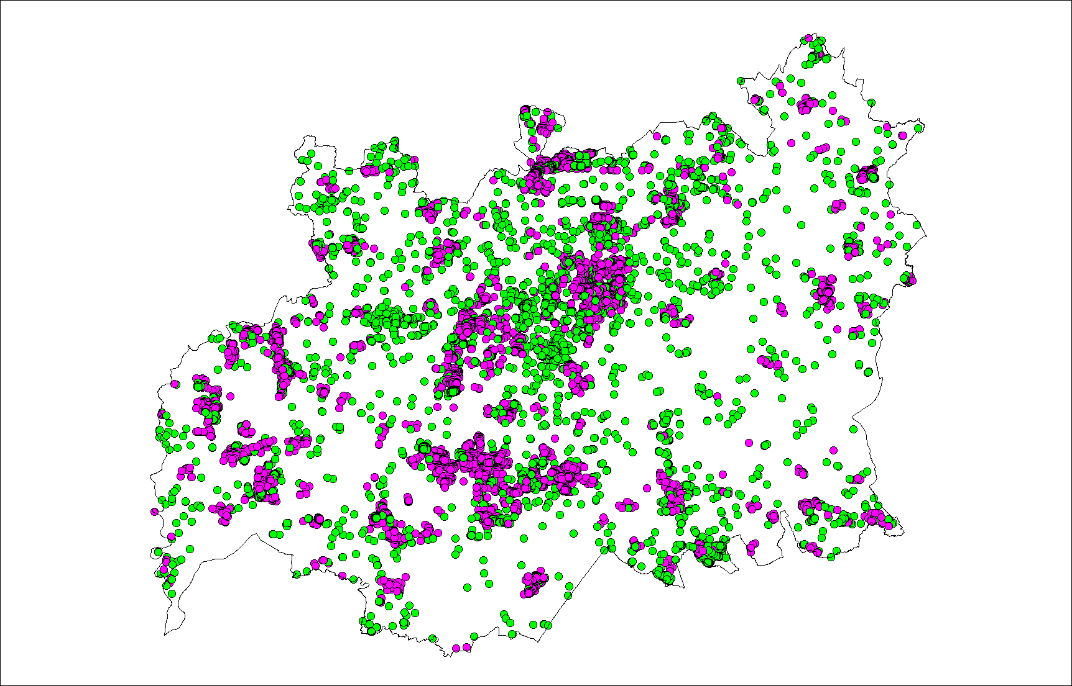

Map 2 Herefordshire

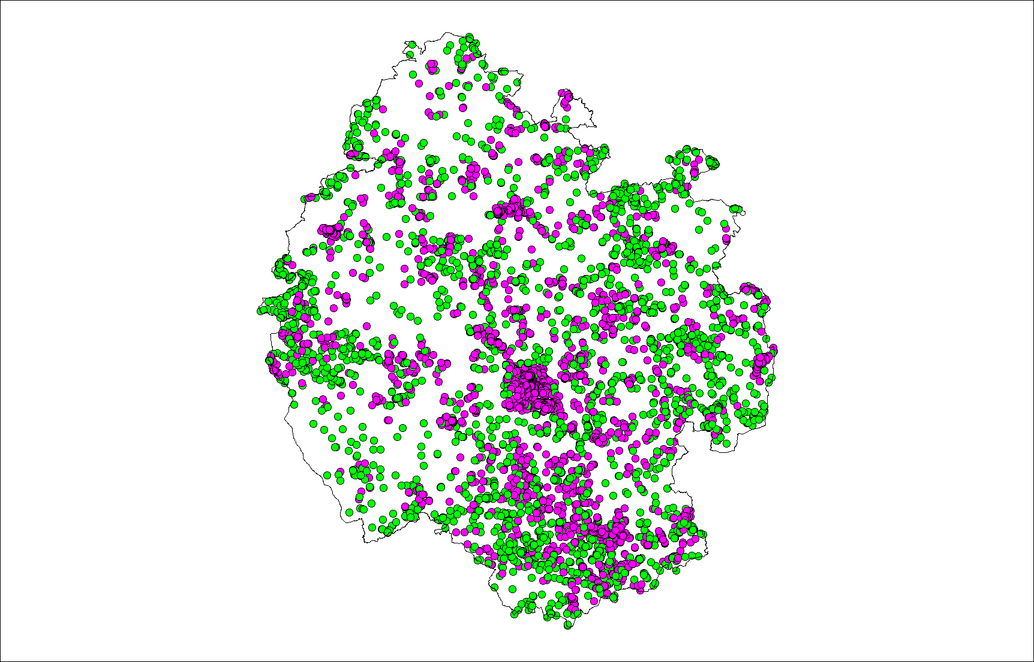

Map 3 Telford and Wrekin

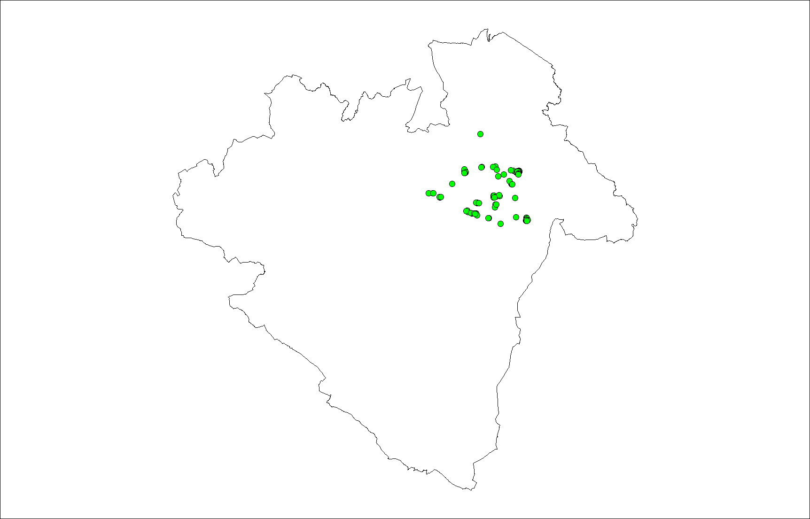

7. PROCUREMENT & DELIVERY MODEL

Fastershire hosted an industry day on February 6th 2020 to describe and discuss Stage 5 of the Fastershire Broadband Strategy, residual areas and procurement approach with potential suppliers. The event was well attended and the proposals positively received.

The DPS procurement will be carried out in accordance with the Public Contracts Regulations 2015 and EU Public Procurement Directives.

The Fastershire Community Grant will be administered as a 2 stage process
- Establish a Dynamic Purchasing System – to on board a number of technically capable suppliers; and
- Periodically launch Mini Competitions – to enable communities to select the Most Economically Advantageous Solution from a range of bids tendered by those Providers that have been accepted onto the DPS.

All suppliers admitted onto the DPS will be required to enter into a DPS Agreement with Herefordshire Council. Thereafter, any supplier that successfully bids for a Mini Competition will enter into contracts directly with the communities that will benefit from the funding.

No Mini Competition will be launched until the results of this Public Consultation have been analysed and the Intervention Area determined.

8. RESPONDING TO THIS STATE AID PUBLIC CONSULTATION

Fastershire are requesting information and supporting evidence in relation to basic and NGA broadband infrastructure within the Intended Intervention Area and wish to hear from all relevant stakeholders (including residents, businesses as well as broadband infrastructure operators).

For the avoidance of doubt, there is no need to respond to this public consultation if you have no comment to make.

For residents and businesses, where this relates to the ability to receive an NGA service, any information provided in response to this State Aid public consultation should as a minimum include (but need not be limited to) the address of the property or area that the submission relates to and the nature of the concern.

If the response is from a broadband infrastructure provider and comments on the NGA White classification of premises within the attached maps and data, or on the wholesale products to offered via the subsidised network, then the submission should also include the specific information set out below.

- The Public Consultation Response Template with any premises within the Intended Intervention Area flagged to show where you currently offer >30Mbps connectivity or separately where you intend to provide such connectivity within 3 years. By ‘covered’ (or ‘passed’) Fastershire means that fixed network infrastructure is or will be available to the premises, potentially subject to a final drop connection, or that the premises are able to receive a suitable quality radio signal over the air interface, potentially subject to the installation of a suitable antenna.
- Supporting evidence for, any current or planned (within the next 3 years) investment in broadband infrastructure in the Intended Intervention Area to include, but need not be limited to:
  - Detailed maps for NGA broadband showing existing and planned coverage, for at least the next 3 years.
  - A detailed description of the technology solution(s) deployed (or to be deployed) in your broadband infrastructure, demonstrating how they meet the definition of NGA Capability.
  - A description of the services/products currently offered, and separately those services/products to be offered within the next 3 years.
  - Installation, annual/monthly subscription, and additional volume or per-service tariffs for those services/products (identifying whether such tariffs are inclusive or exclusive of VAT).
  - Upload and download speeds typically experienced by end-users, and how these may vary by factors such as distance, increased take-up or demand, contention, etc.
  - Appropriate indicators of the quality of services (e.g. contention ratios, bandwidth allocation per user, etc), including any characteristics (e.g. latency, jitter) that are required to support advanced services such as video conferencing or HD video streaming.
  - Evidence to substantiate actual or planned coverage claims, including business cases and evidence of available funding to enable plans to be fulfilled.
  - Details and planned timing of roll-out of any future investments, including further investments required to cope with future increases in take-up or demand.

Please supplement the required information above with any supporting evidence as you consider appropriate (e.g. links to public websites).

Fastershire would also be interested to hear from operators their views as to the types of wholesale access products they would like to see offered on any newly created subsidised NGA network infrastructure. This information may inform the intervention design. Please note that we are not obliged to include these products in the invitation to tender.

To reiterate, the DPS and Mini Competitions which are anticipated to follow this consultation will be defined at a premise level. This is for the benefit of all, not least private providers. Whilst the Partners wish to avoid any overspill into the network footprint of commercial providers they are unwilling to allow citizens premises to fall through the gaps as a result of either defining postcode areas as in or out of scope where only partial coverage exists. As any submission will be treated as commercially sensitive and only re-presented on an aggregated basis, we trust that providers understand our reasoning and comply in good faith. Where premise level detail is not forthcoming but where the Authorities are in receipt of alternative evidence of availability at that level for any given supplier, that evidence will be assessed against the request for information requirements set out above.

9. TIMESCALES

This consultation will begin on Monday June 29th 2020 and remain open until 12 noon on Monday August 3rd.

10. PRO-CONTRACT ACCESS

The Public Consultation Response Template will be released to providers via the Supplying the South West Portal Pro-Contract once a signed Partners Standard Form PSMA Contractor License has been submitted. The Contractor License is a requirement of the licensing arrangements in place with the owner of the premise data (Ordnance Survey).

The Pro-Contract site is independent from the Council’s own email/web site and allows access and retrieval of large files such as the Response Template. In creating a log on user ID and password, you will be automatically registered to receive email alerts for the forthcoming DPS Invitation to Tender documentation. Instructions for this are set out below.

Please note that the data you provide in your response will be treated as commercially confidential to Herefordshire Council, albeit that it may be necessary to share some/all of your response data with our professional advisors and/or DCMS/BDUK, Ofcom, the National Competence Centre and the European Commission. It should also be noted that it is a State Aid requirement to utilise this information to produce State Aid maps to define white, grey and black areas for basic and NGA broadband. These maps will be published as part of the Public Consultation process and will be utilised to define the intervention area. However, please note that these published maps will be assimilated utilising data from all relevant operators and will not be directly attributed to a single source. The final maps that will be used for procurement purposes will be published shortly after the conclusion of this State aid public consultation.

If you have any questions about any of the above, please contact Matt Smith at Fastershire msmith3@herefordshire.gov.uk

INSTRUCTIONS TO SUPPLIERS FOR ACCESS TO PRO-CONTRACT:

Go to www.supplyingthesouthwest.org.uk and click on “Supplier Registration” located on the left hand side. This will open a new page and welcome you to the Supplier Registration Wizard.

Click on “Next” (at the bottom of the page) to access the registration from which comprises of 5 steps for you to complete. You MUST complete all the mandatory fields that are indicated with a red asterisk *

Step one is Contact Information & Security – These details will be the main contact details used for any procurement exercise. The email entered here will be the email address that messages are sent to confirming registration details, and all other system communications that may take place in all tender process. We recommend using a generic email to cover for leave and sickness.

Step Two is Company Information – If any of the fields do not apply to your company enter n/a

Step Three is Category Selection - This is where you can register your company to receive automatic e-mail notifications of new opportunities that have been published that may be of interest to your company. For this project ensure that you are registered under Category Code 72000000: IT services: consulting, software development, Internet and support; and, 32000000: Radio, television, communication, telecommunication and related equipment

Step Four is Council Selection - This is where you select the Area/Council that you want to receive automatic e-mail updates from. For this project select Herefordshire Council.

Step Five is Conditions and Privacy – This is where you need to agree to DUE north’s (the host company of Pro-Contract) Terms and Conditions and the privacy policy. If you do not agree to these you will be unable to use the system.

Once this registration is complete, you will receive a confirmation e-mail and a further two e-mails informing you of your username and password.

If you require any assistance regarding the Supplying the South West Portal or Pro-Contract System then please contact Due North on swsupport@due-north.com or 0844 334 5204, lines are open Monday – Friday 08:30 to 17:00 (excluding English bank holidays)

http://eur-lex.europa.eu/LexUriServ/LexUriServ.do?uri=OJ:C:2013:025:0001:0026:en:PDF
See Footnote 66 of the Commission’s Guidelines - this sets out that the subsidised network should be pro-competitive (i.e. allow for effective access at different levels of the infrastructure).

